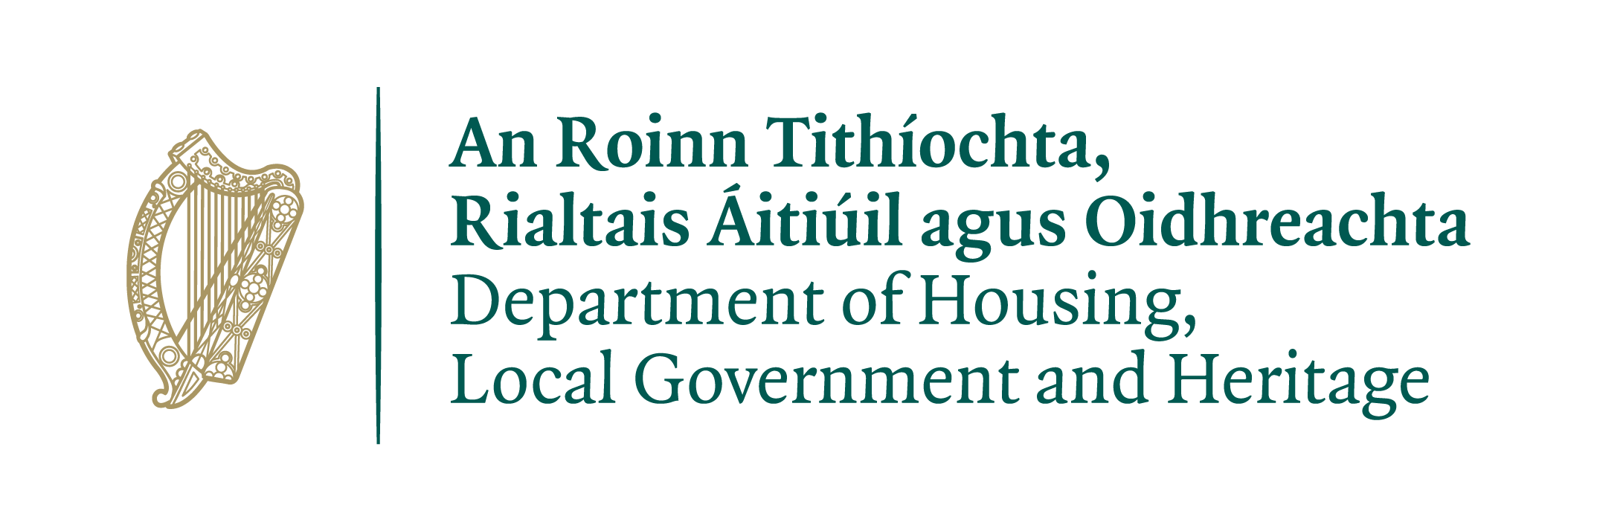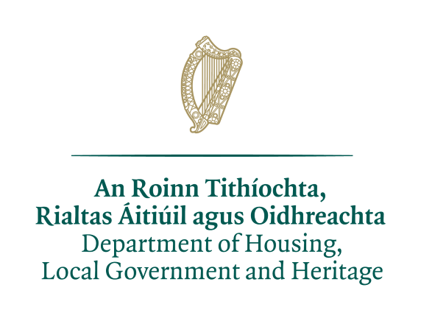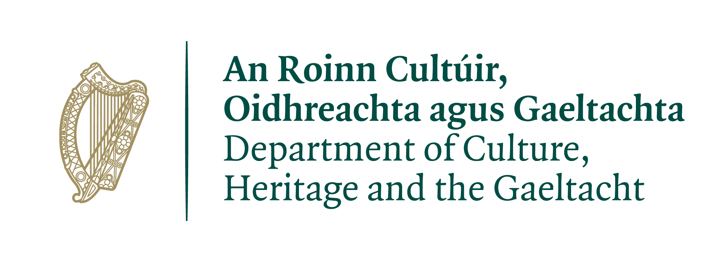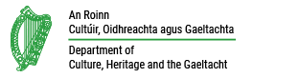
Ireland’s Tentative List for World Heritage Sites
Application Form
(For Serial Properties one form per property is required)

Please use The National Monuments Service’s https://www.worldheritageireland.ie/tentative-list/ as a reference in the completion of this application form.

Check to confirm that you have submitted the following documents with your application form*:
- Signed letter of consent by landowner
- Letters of support by community members and stakeholder organizations
- Supporting photos and images (maximum of 10)
- Map of site

*Please note that your application will not be considered unless all necessary documents, as outlined above, are submitted.
**Letters of support are encouraged but not required. Any such letters submitted will be taken into account when assessing the strength of the application
By submitting this completed form, you authorize The National Monuments Service (NMS), Department of Housing, Local Government and Heritage to collect, use, disclose and otherwise manage the personal information and materials (e.g. statements, text, photos) you provide. Further, you warrant, covenant and agree that to the extent the completed form includes the personal information of third parties you have enclosed the consent of those third parties to disclose the personal information to NMS for the purpose of collecting, using, disclosing and otherwise managing the personal information and materials.
You agree that you have received and enclosed consent from all identified people in submitted photos for NMS to collect, use, disclose to relevant parties and otherwise manage the photos. The personal information and materials you submit will be used only for the purposes of reviewing the application for Ireland’s Tentative List for World Heritage Sites and will be protected pursuant to the Data Protection Act 2018. For more information, contact: worldheritage@housing.gov.ie
Please note that all information provided is subject to the provisions of the Freedom of Information Act 2014 and may be subject to an access request, which will be carried out in accordance with the FOI Act. For further information about the FOI Act, see: https://foi.gov.ie.
Date |  | Applicant Name Printed | X  Applicant Signature
Print, sign and send your application to:
worldheritage@housing.gov.ie by 30 June 2021
Deadlines
The final deadline for receipt of applications is 30 June, 2021.
Applications will be appraised internally by NMS, which may seek further information. All applicants will be informed whether or not their application will be sent for assessment by an international committee to decide whether the sites have Outstanding Universal Value as required for World Heritage Sites.
In relation to word counts outlined below, please adhere to them as closely as possible. However, in the case of serial sites where one omnibus form is used, the word count is per site and requested detail should be supplied for each site in the sections below.

OFFICE USE:
Application number
Date of Receipt
PART A – APPLICANT INFORMATION
Name
Title and Organization
(if applicable)
Mailing Address
Email
Telephone
Preferred language of communication (English/Gaeilge)

PART B – SITE INFORMATION
Site name
Location / Address
Geographic coordinates (latitude & longitude or ITM)

 | Reference in Operational guidelines
PART C – heritage values for which the site is proposed
Section 1 – Identification of the Site
Section 1A - Indicate category:  Natural  Cultural  Mixed (Cultural and Natural)  Cultural Landscape | 45-47
Section 2 – Description and History
Section 2A – Description of Site (maximum 200 words)
Provide a brief description of the proposed site, including its main heritage features and relevant geographic characteristics. The main focus should be on those features which are relevant to its Outstanding Universal Value.
Section 3 – Proposed Outstanding Universal Value (OUV)
*Note: all sections below must be completed unless otherwise indicated
Section 3A – Justification for adding the Site to Ireland’s Tentative List.  Propose why the site may have Outstanding Universal Value. OUV encapsulates why the site is of importance to all humanity. The description should summarize the main attributes which demonstrate the site’s OUV. It should be written with careful reference to the Operational Guidelines for the Implementation of the World Heritage Convention. (maximum of 200 words) | 49-53
Section 3B – Proposed Outstanding Universal Value by criteria  State which one or more of the 10 criteria for Outstanding Universal Value are being proposed for this site and describe briefly why each was chosen.  *Refer to NMS’s Information Document – Updating Ireland’s Tentative List for World Heritage Sites or the Operational Guidelines for the definition of each criterion.  Operational Guidelines: https://whc.unesco.org/en/guidelines/ | 77-78
World Heritage criterion | X | Why was this criterion chosen? (max 50 words)
(i) |  | to represent a masterpiece of human creative genius;
(ii) |  | to exhibit an important interchange of human values, over a span of time or within a cultural area of the world, on developments in architecture or technology, monumental arts, town-planning or landscape design;
(iii) |  | to bear a unique or at least exceptional testimony to a cultural tradition or to a civilization which is living or which has disappeared;
(iv) |  | to be an outstanding example of a type of building, architectural or technological ensemble or landscape which illustrates (a) significant stage(s) in human history;
(v) |  | to be an outstanding example of a traditional human settlement, land-use, or sea-use which is representative of a culture (or cultures), or human interaction with the environment especially when it has become vulnerable under the impact of irreversible change;
(vi) |  | to be directly or tangibly associated with events or living traditions, with ideas, or with beliefs, with artistic and literary works of outstanding universal significance. (The Committee considers that this criterion should preferably be used in conjunction with other criteria);
(vii) |  | to contain superlative natural phenomena or areas of exceptional natural beauty and aesthetic importance;
(viii) |  | to be outstanding examples representing major stages of earth's history, including the record of life, significant on-going geological processes in the development of landforms, or significant geomorphic or physiographic features;
(ix) |  | to be outstanding examples representing significant on-going ecological and biological processes in the evolution and development of terrestrial, fresh water, coastal and marine ecosystems and communities of plants and animals;
(x) |  | to contain the most important and significant natural habitats for in-situ conservation of biological diversity, including those containing threatened species of outstanding universal value from the point of view of science or conservation.
Section 3C – Authenticity of the site (*for cultural criteria only)  Describe the authenticity of the site. Authenticity concerns the measure of how well and how truthfully a site’s features express potential OUV. (maximum of 200 words) | 79-86
Section 3D – Integrity of the site (for both cultural and natural criteria)  Describe the integrity of the site. Integrity is a measure of the completeness or intactness of the features that convey proposed OUV. Key areas to consider are wholeness, adequate size, and absence of threats. (maximum of 200 words) | 87-95
Section 3E –Indicate what distinguishes this site from other similar heritage properties around the world, including other properties on the World Heritage List? Give details on its significance in relation to a maximum of 5 properties of comparable heritage value found worldwide. (maximum of 400 words)
*Desirable but not required.
Section 3F –Identify whether the site addresses a particular gap or under-represented area or theme on the World Heritage List.  (maximum of 200 words)  *Desirable but not required. | 54-59
Section 4 – State of Conservation
Section 4A –Describe the current state of conservation of the site, including details on any potential environmental or development threats to the site, or risks presented by natural disasters. Indicate any mitigation measures in place for the threats identified. (maximum of 200 words)
Section 5 – Protection and Management
Section 5A - Demonstrate how the property has adequate long-term legislative, regulatory, institutional and/or traditional protection. If protection measures are not currently in place, indicate what protection mechanism will be afforded the property in the near future, and include a supporting letter from the relevant authority. (maximum of 400 words) | 98
Section 5B - List the principal owners or competent authorities of the site. As an annex, include a letter from the site owner indicating their consent for this submission.
*For sites with multiple landowners, such as urban complexes, provide a breakdown of the number of individual legal property parcels with information on zoning (i.e. commercial versus residential). In this case, the letter of support should come from the relevant governing jurisdiction.
Section 5C –List any community groups and/or major stakeholders with an interest in the site and provide a brief summary of their views regarding its proposed inclusion on the Tentative List. (maximum of 200 words)

Section 5D -Summarize any discussions you’ve had with the National Parks and Wildlife Service, National Monuments Service, OPW and/or the local authority regarding your application. (maximum of 400 words)
Section 5E –Describe whether a management plan is in place, or how it would be developed, that specifies how the Outstanding Universal Value of the property would be protected, presented and transmitted to future generations. (maximum of 400 words). Include plan if it exists. | 108-118
Section 6 – Documentation
Section 6A – Applications can include a limited number of additional support materials beyond this completed application form. Please help ensure that the review of your application focusses on directly relevant supporting materials, which give evidence of and/or reinforce the information provided in this application form. All supporting materials should be referenced in the appropriate section of this application form; identify the specific pages within the supporting materials that are critical to substantiating the relevance of the application.
Section 7 - Maps
Section 7A –Include a map of the site, with additional insert maps as deemed necessary. The map should include coordinates (latitude & longitude or ITM) and a clear boundary identification.
List of annexed items (please number)

The Department’s Privacy Statement can be found on our website at the following link:
https://www.worldheritageireland.ie/tentative-list/

The procedures, criteria and requirements for the inscription of properties on the World Heritage List are prescribed in the Operational Guidelines for the Implementation of the World Heritage Convention.

